**DIGITAL IMAGE COMPRESSION**

**Abstract**

We have to transmit and store photos or pictures in numerous everyday life applications. Littler the picture, less is the expense related to transmission and capacity. So we frequently need to apply information pressure procedures in order to decrease the capacity limit devoured by the picture. One methodology is to utilize Singular Value Decomposition (SVD) on the picture grid. In this technique, the computerized picture is given to SVD. SVD refactors the given computerized picture into three matrices. Particular qualities are utilized to refactor the picture and toward the finish of this procedure, the picture is spoken to with little arrangement of qualities, thus decreasing the capacity limit required by the picture. The objective here is to accomplish the image compression while safeguarding the imperative highlights which portray the first picture. SVD can be adjusted to any discretionary, square, reversible and non-reversible network of m × n estimate. Compression ratio and Mean Square Error is utilized as performance matrices.

# 

# **Introduction**

Image compression is a type of data compression applied to digital images, to reduce their cost for storage or transmission. Algorithms may take advantage of visual perception and the statistical properties of image data to provide superior results compared with generic data compression methods which are used for other digital data.

**Literature Review**

Every symmetric matrix A can be factored as A = PDP T' where Pis an orthogonal matrix and Dis a diagonal matrix displaying the eigenvalues of A. If A is not symmetric, such a factorization is not possible. We may still be able to factor a square matrix A as A = PDP-1, where D is as before but P is now simply an invertible matrix. However, not every matrix is diagonalizable, so it may surprise you that we will now show that every matrix (symmetric or not, square or not) has a factorization of the form A = PDQ T' where P and Q are orthogonal and D is a diagonal matrix.This remarkable result is the singular value decomposition (SVD), and it is one of the most important of all matrix factorizations.

**Some Applications of the Eigenvalues and Eigenvectors of a square matrix**

1. Communication systems: Eigenvalues were used by Claude Shannon to determine the theoretical limit to how much information can be transmitted through a communication medium like your telephone line or through the air. This is done by calculating the eigenvectors and eigenvalues of the communication channel (expressed a matrix), and then waterfilling on the eigenvalues. The eigenvalues are then, in essence, the gains of the fundamental modes of the channel, which themselves are captured by the eigenvectors.

2. Designing bridges: The natural frequency of the bridge is the eigenvalue of smallest magnitude of a system that models the bridge. The engineers exploit this knowledge to ensure the stability of their constructions. [Watch the video on the collapse of the Tacoma Narrow Bridge which was built in 1940]

3. Designing car stereo system: Eigenvalue analysis is also used in the design of the car stereo systems, where it helps to reproduce the vibration of the car due to the music.

4. Electrical Engineering: The application of eigenvalues and eigenvectors is useful for decoupling three-phase systems through symmetrical component transformation.

5. Mechanical Engineering: Eigenvalues and eigenvectors allow us to "reduce" a linear operation to separate, simpler, problems. For example, if a stress is applied to a "plastic" solid, the deformation can be dissected into "principle directions"- those directions in which the deformation is greatest. Vectors in the principle directions are the eigenvectors and the percentage deformation in each principle direction is the corresponding eigenvalue.

Oil companies frequently use eigenvalue analysis to explore land for oil. Oil, dirt, and other substances all give rise to linear systems which have different eigenvalues, so eigenvalue analysis can give a good indication of where oil reserves are located. Oil companies place probes around a site to pick up the waves that result from a huge truck used to vibrate the ground. The waves are changed as they pass through the different substances in the ground. The analysis of these waves directs the oil companies to possible drilling sites.

6. Cinematography :When we watch a movie on TV/movie theater the picture(s)/movie we see is actually 2D, we do not get much information from the 3D real world it is capturing. That is because the principal eigenvector is more towards 2D plane. The picture is being captured and any small loss of information (depth) is inferred automatically by our brain. Each scene requires certain aspects of the image to be enhanced, that is the reason the camera man/woman chooses his/her camera angle to capture most of those visual aspects. (Apart from color of costume, background scene and background music)

7. Finance: The eigenvalues and eigenvectors of a matrix are often used in the analysis of financial data and are integral in extracting useful information from the raw data. They can be used for predicting stock prices and analyzing correlations between various stocks, corresponding to different companies. They can be used for analyzing risks. There is a branch of Mathematics, known as Random Matrix Theory, which deals with properties of eigenvalues and eigenvectors, that has extensive applications in Finance, Risk Management, Meteorological studies, Nuclear Physics, etc.

8. Vibration :Eigenvalue problems occur naturally in the vibration analysis of mechanical structures with many [degrees of freedom](https://en.wikipedia.org/wiki/Degrees_of_freedom_(mechanics)).. A simple nontrivial vibration problem is the motion of two objects with equal masses m attached to each other and fixed outer walls by equal springs with spring constants k. This can be reduced to a generalized eigenvalue problem by [algebraic manipulation](https://en.wikipedia.org/wiki/Quadratic_eigenvalue_problem#Methods_of_Solution) at the cost of solving a larger system. The orthogonality properties of the eigenvectors allows decoupling of the differential equations so that the system can be represented as linear summation of the eigenvectors. The eigenvalue problem of complex structures is often solved using [finite element analysis](https://en.wikipedia.org/wiki/Finite_element_analysis), but neatly generalize the solution to scalar-valued vibration problems.

9. **Population Growth Model**

Population Growth Matrices can be used to form models for population growth. The first step in this process is to group the population into age classes of equal duration. For instance, if the maximum life span of a member is years, then the following intervals represent the age classes. 3 0, L n 2

First age class Second age class th age class The age distribution vector represents the number of population members in each age class, where Over a period of years, the probability that a member of the th age class will survive to become a member of the age class is given by where The average number of offspring produced by a member of the th age class is given by where These numbers can be written in matrix form, as follows. Multiplying this age transition matrix by the age distribution vector for a specific time period produces the age distribution vector for the next time period. Axi 5 xi11 .Eigenvalues are not only used to explain natural occurrences, but also to discover new and better designs for the future. Some of the results are quite surprising. If you were asked to build the strongest column that you could to support the weight of a roof using only a specified amount of material, what shape would that column take? Most of us would build a cylinder like most other columns that we have seen. However, Steve Cox of Rice University and Michael Overton of New York University proved, based on the work of J. Keller and I. Tadjbakhsh, that the column would be stronger if it was largest at the top, middle, and bottom. At the points of the way from either end, the column could be smaller because the column would not naturally buckle there anyway. Does that surprise you? This new design was discovered through the study of the eigenvalues of the system involving the column and the weight from above. Note that this column would not be the strongest design if any significant pressure came from the side, but when a column supports a roof, the vast majority of the pressure comes directly from above. Very roughly then, the eigenvalues of a linear mapping is a measure of the distortion induced by the transformation and the eigenvectors tell you about how the distortion is oriented. It is precisely this rough picture which makes PCA (Principal Component Analysis = A statistical procedure) very useful.

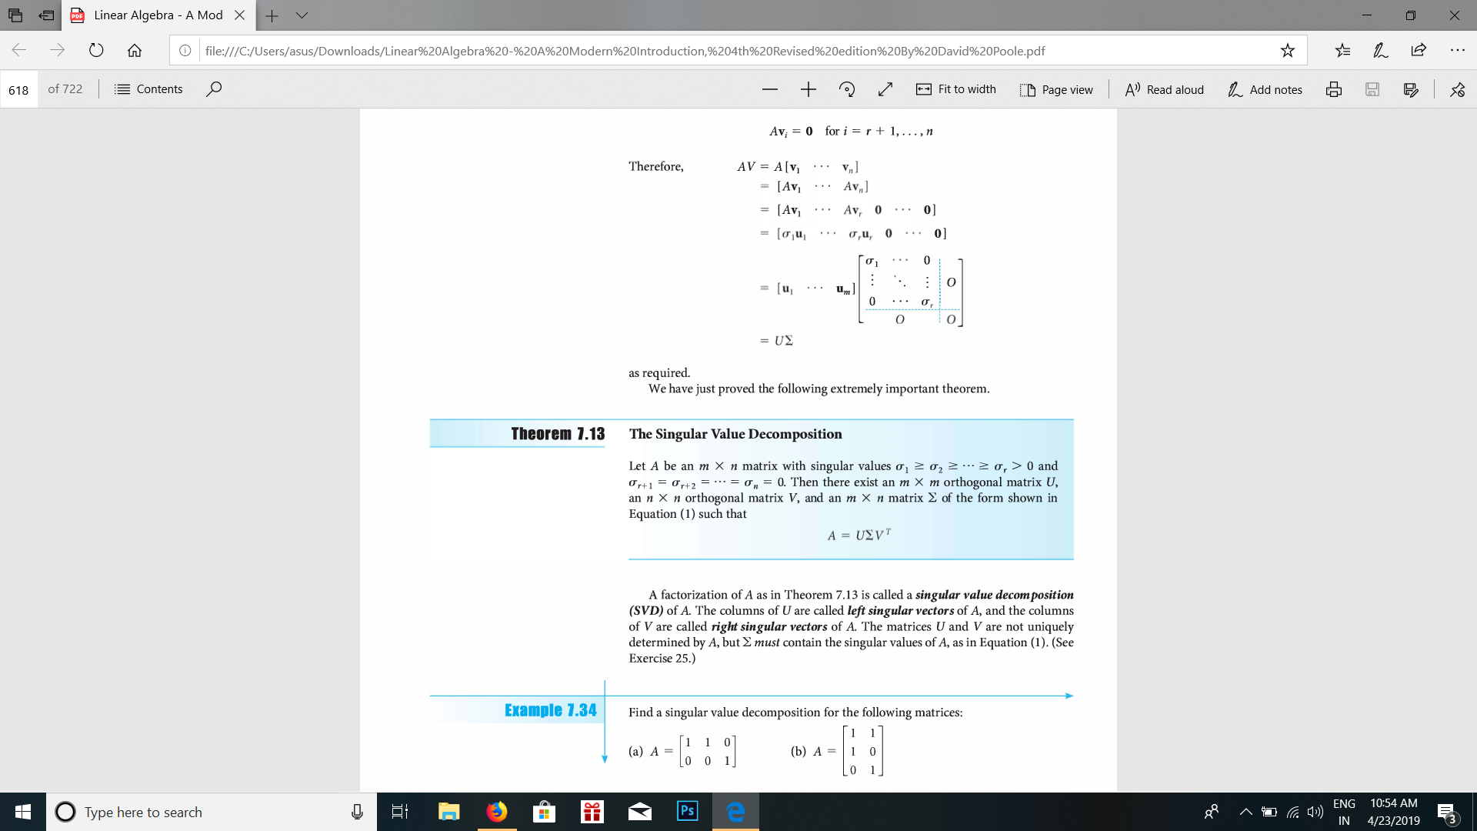

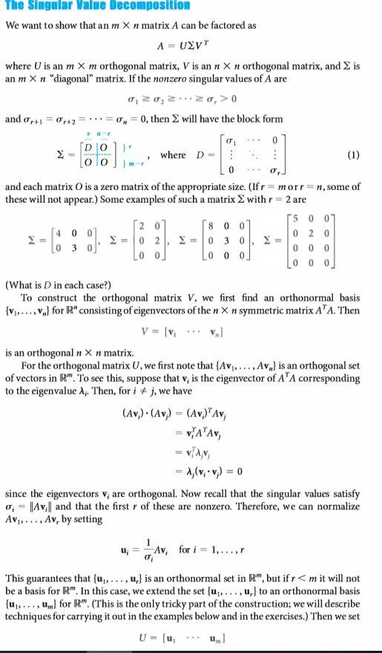

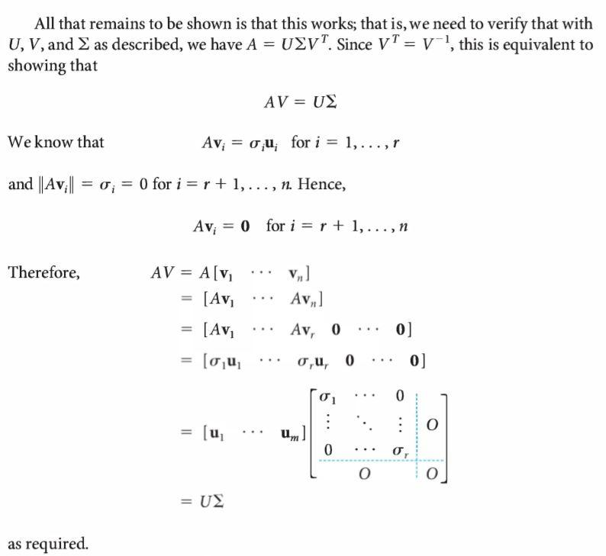

**Problem Statement**

To compress image digitally using the concept of SVD.

**Solution Methods**

Picture pressure is limiting the size in bytes of a designs record without debasing the nature of the picture to an unsuitable dimension. The decrease in record estimate enables more pictures to be put away in a given measure of circle or memory space. It likewise diminishes the time required for pictures to be sent over the Internet or downloaded from Web pages.

There are a few distinctive manners by which picture records can be packed. For Internet use, the two most basic compressed realistic picture designs are the JPEG group and the GIF position. The JPEG technique is all the more frequently utilized for photos, while the GIF strategy is generally utilized for line workmanship and different pictures in which geometric shapes are moderately straight forward.

**Conclusion:**

It is seen that SVD gives great compression results with less computational intricacy contrasted with other pressure procedures. A specific level of pressure as required by an application can be accomplished by picking a proper estimation of k (for example the number of eigen values). As it were, the level of compression can be fluctuated by shifting the estimation of k. In any case, to accomplish a high estimation of compression ratio picture quality is to be yielded. Accordingly, it is required to choose a legitimate estimation of k to pick between pressure proportion and picture quality. When the estimation of k is chosen for a particular application or for explicit video a similar benchmark can be utilized for every one of the edges. Other than picture compression, SVD discovers application in commotion decrease, face acknowledgment, watermarking, and so on.

**References**

1. <https://en.wikipedia.org/wiki/Image_compression>
2. [https://whatis.techtarget.com/definition/image-compression](https://whatis.techtarget.com/image-compression)
3. <https://www.e-olymp.com/en/problems/1817>

**Appendices**

**Code:**

**For black and white**

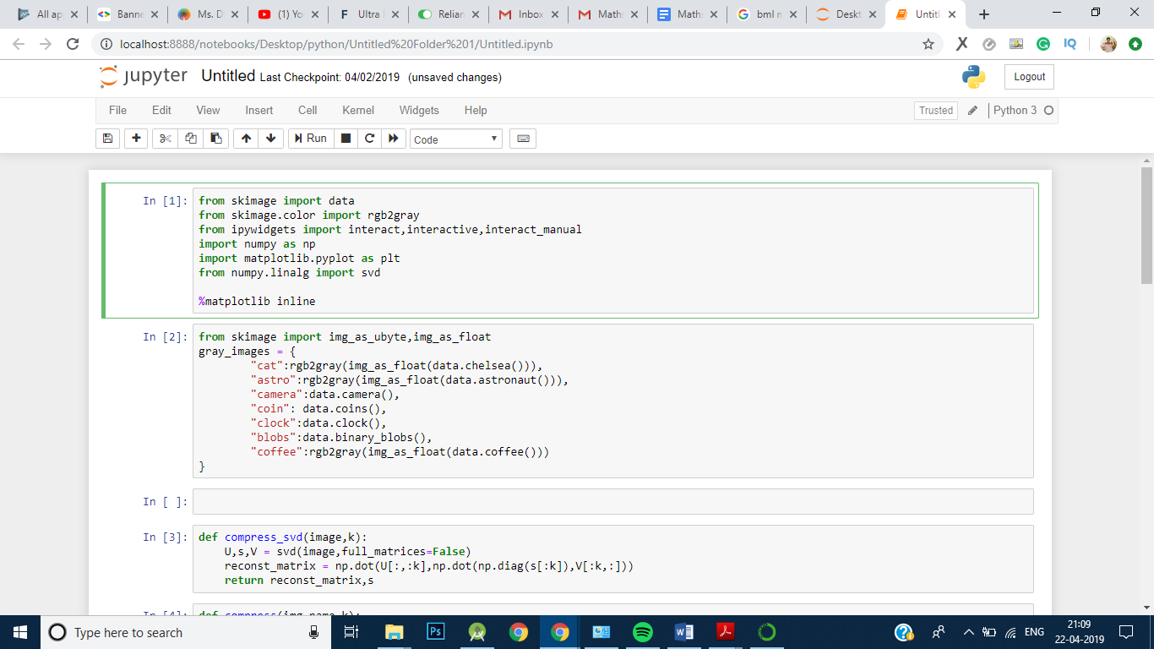 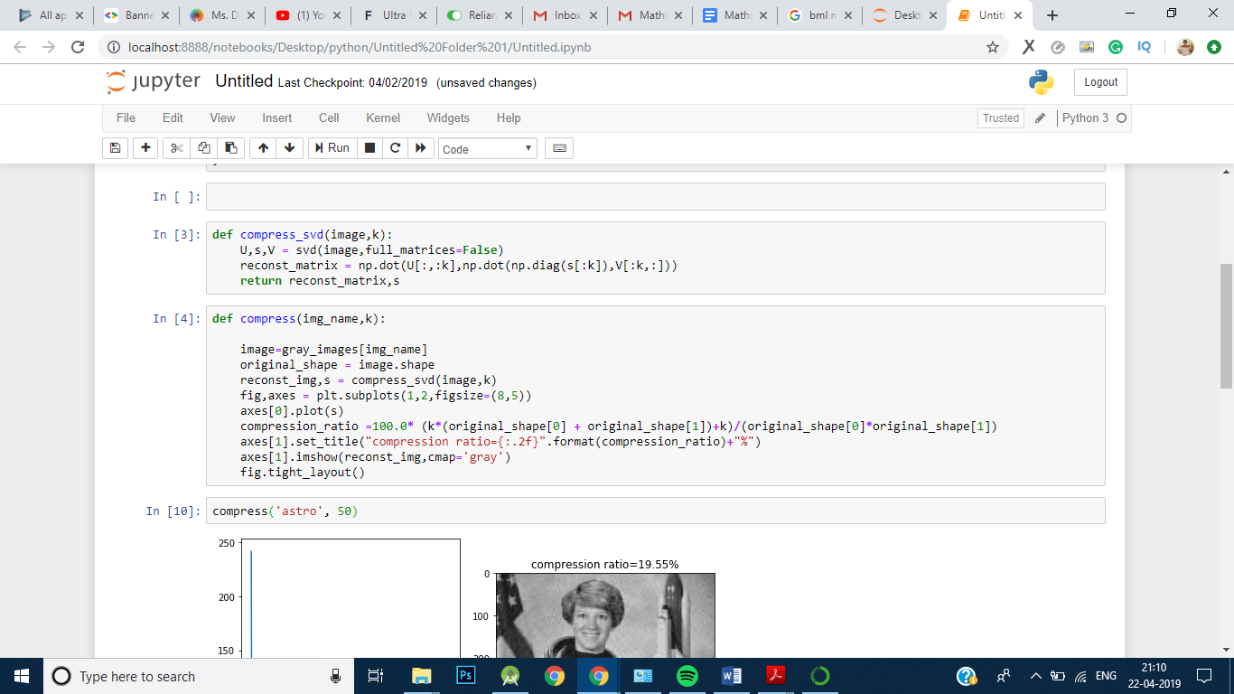

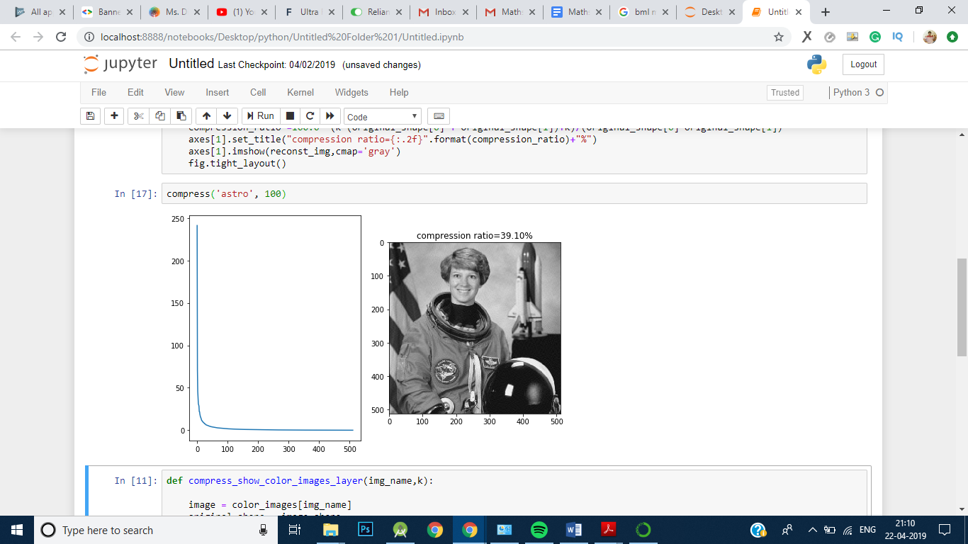 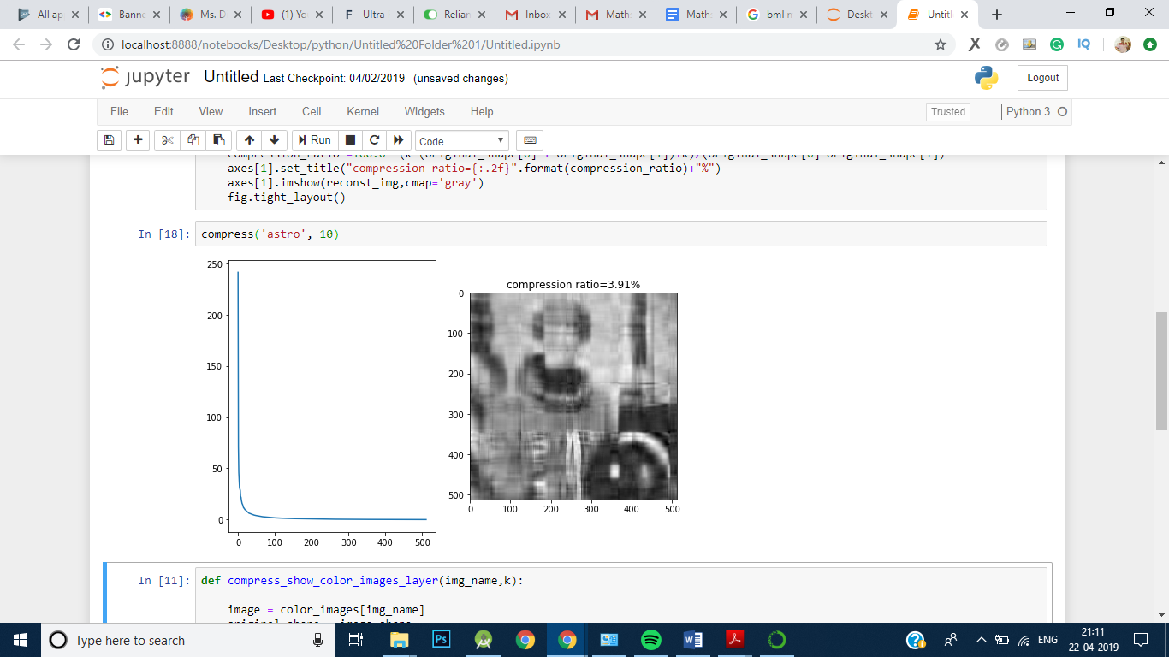

**For Coloured**

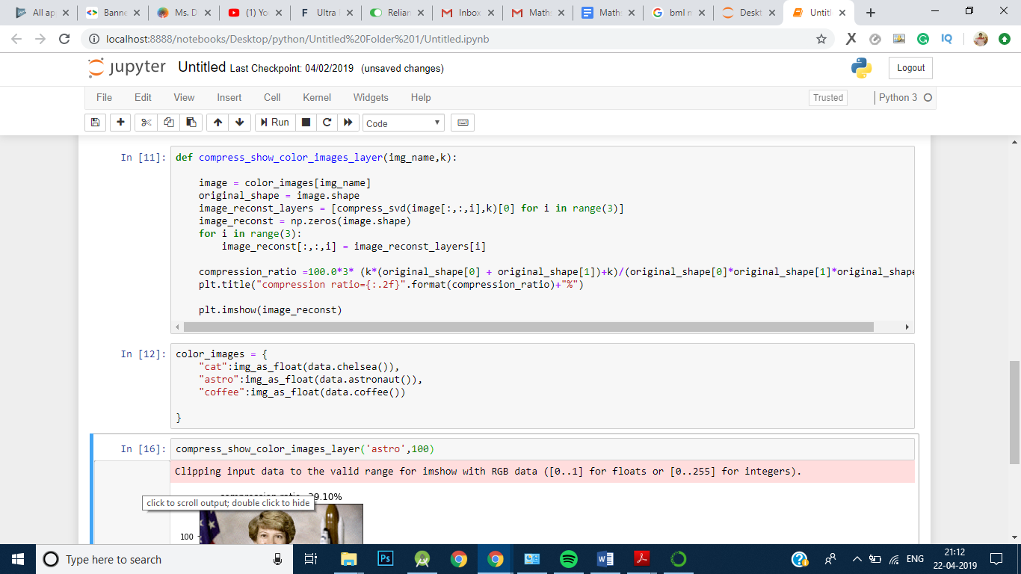

**Before:**

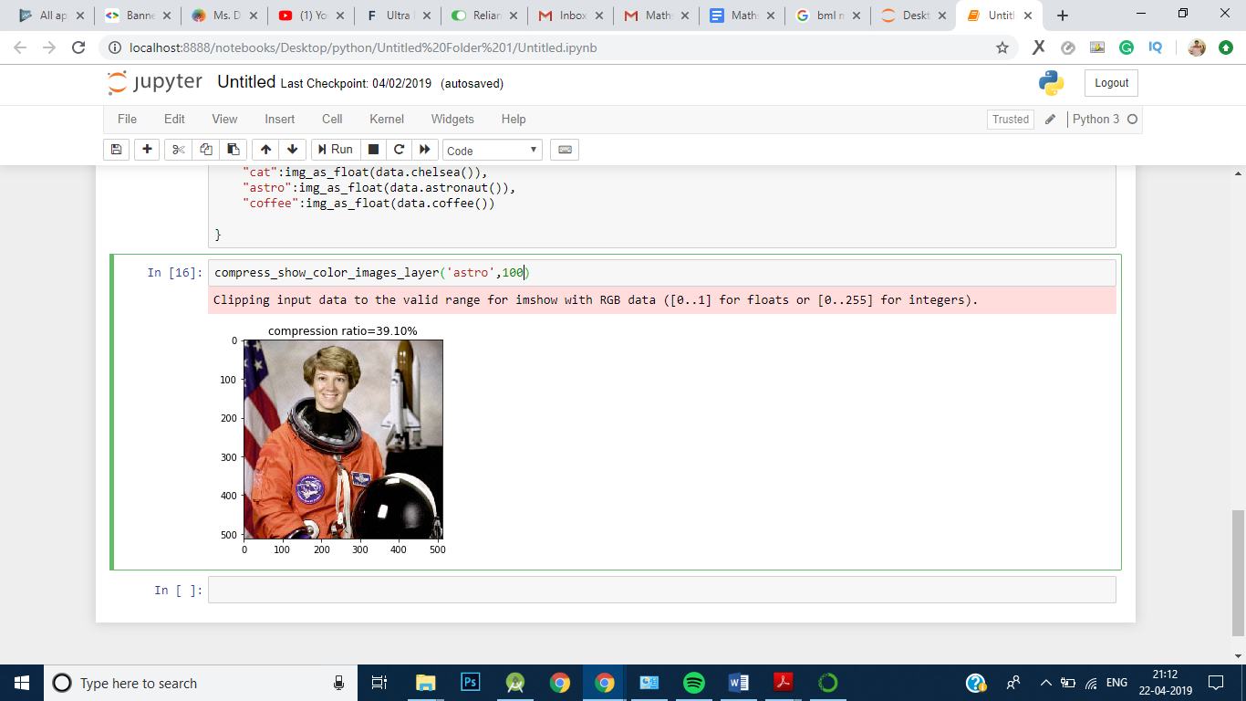

**After:**

